**Compilation**

jamess-imac:program AcousticTime$ g++ -c FileCheck.cpp

jamess-imac:program AcousticTime$ g++ -c Input.cpp

jamess-imac:program AcousticTime$ g++ -c LinearRegression.cpp

jamess-imac:program AcousticTime$ g++ -c StringToFloat.cpp

jamess-imac:program AcousticTime$ g++ -o program4A program4A.cpp FileCheck.o Input.o LinearRegression.o StringToFloat.o

jamess-imac:program AcousticTime$

**Test 1**

jamess-imac:program AcousticTime$ ./program4A

What would you like to do?

Enter 1 to read from file.

Enter 2 to write to file.

Enter 3 to modify a file.

Enter 4 to calculate linear regression.

Enter 0 to quit.

Choice: 4

Enter the x-axis values filename: xvalues

Enter the y-axis values filename: yvalues

B0 = -22.5524

B1 = 1.72793

**Test 2**

jamess-imac:program AcousticTime$ ./program4A

What would you like to do?

Enter 1 to read from file.

Enter 2 to write to file.

Enter 3 to modify a file.

Enter 4 to calculate linear regression.

Enter 0 to quit.

Choice: 4

Enter the x-axis values filename: xvaluesb

Enter the y-axis values filename: yvalues

B0 = -23.9238

B1 = 1.43097

**Test 3**

jamess-imac:program AcousticTime$ ./program4A

What would you like to do?

Enter 1 to read from file.

Enter 2 to write to file.

Enter 3 to modify a file.

Enter 4 to calculate linear regression.

Enter 0 to quit.

Choice: 4

Enter the x-axis values filename: xe

Enter the y-axis values filename: yn

B0 = 155.929

B1 = -0.482143

**Test 4**

jamess-imac:program AcousticTime$ ./program4A

What would you like to do?

Enter 1 to read from file.

Enter 2 to write to file.

Enter 3 to modify a file.

Enter 4 to calculate linear regression.

Enter 0 to quit.

Choice: 4

Enter the x-axis values filename: xe

Enter the y-axis values filename: yt2

B0 = 101.806

B1 = -0.0229592

**UML Class Diagram**

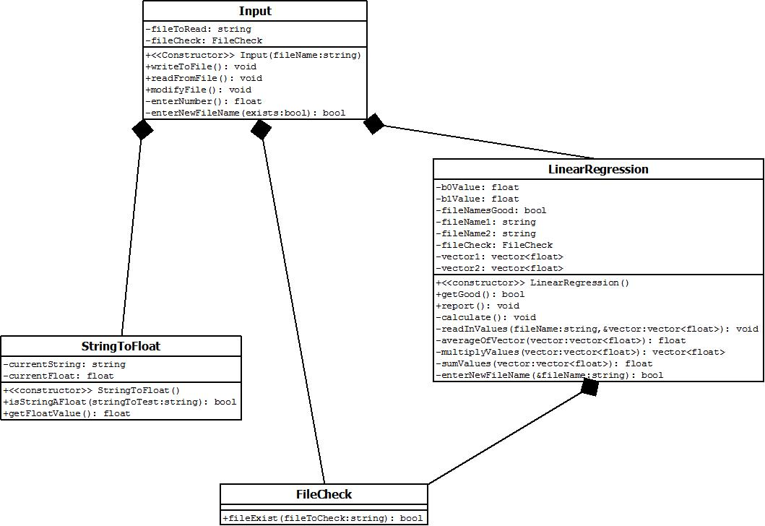

**UML Use Case Diagram**

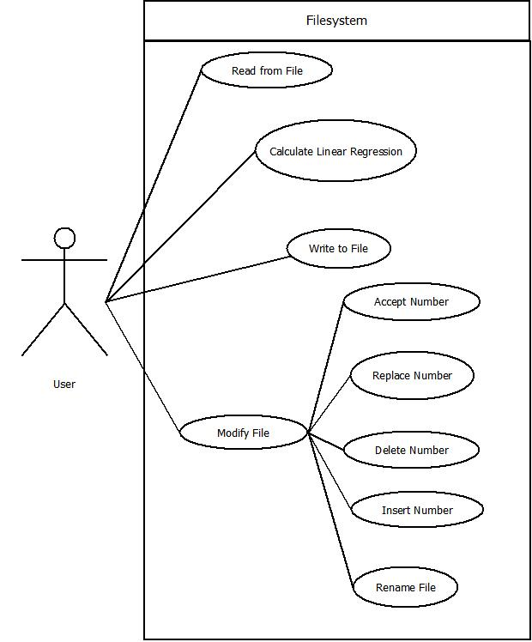

|  |  |  |  |  |
| --- | --- | --- | --- | --- |
| **Test** | **B0 Expected** | **B1 Expected** | **B0 Actual** | **B1 Actual** |
| **1** | -22.55 | 1.7279 | -22.5524 | 1.72793 |
| **2** | -23.92 | 1.4310 | -23.9238 | 1.43097 |
| **3** | NA | NA | 155.929 | -0.482143 |
| **4** | NA | NA | 101.806 | -0.0229592 |